MONTANA STATE UNIVERSITY

Department of Mechanical and Industrial Engineering

ETME 489R-001 CAPSTONE: MECHANICAL ENGINEERING TECHNOLOGY DESIGN I

and

EMEC 489R-001 CAPSTONE: MECHANICAL ENGINEERING DESIGN I

Battle Bot Group 3

by

Cole Trugman

Ivan Albert

Nishagar Raventhiran

for: {Rob Larson, David Miller, Craig Shankwitz, and James Black}

Prepared to Partially Fulfill the Requirements for EMEC 489/ETME489

Department of Mechanical Engineering Montana State University Bozeman, MT 59717

December 10th, 2018

# Executive Summary

This ME/MIE capstone battlebots project is intended to showcase student design and innovation in a challenging, fun, and entertaining event. The objective during the competition is to disable the opponent's battlebot while surviving to fight in the following 3-minute-long round after an allowed 5 minute “pit stop”, all while being prepared to maneuver around arena obstacles designed by another group to hinder and damage the bots. The competition has 3 rounds in total. The design goal is to create an original design for a robot utilizing either new or re-purposed components.

Aside from good sportsmanship/conduct, the competition guidelines provided most of the design constraints and considerations. These constraints include but are not limited to: bot weight, bot size, weapon limitations (such as no flames, explosives, blades, or chemicals), cost (less than $1000), and include a master power disconnect switch.

The method used to ideate and build a formidable bot included spectating and studying televised battle bot competitions as well less professional garage-built bots on Youtube to take note of successful and unsuccessful bot shapes, sizes, weapons, defenses, and drive systems. Weighing the pros and cons of the systems seen as well as new ideas generated by the team led to the decision to use a rotational momentum based “roller” to cause damage, a short, rectangular aluminum body to resist damage, and a repurposed Playstation 3 controller to communicate with and control weapon and drive motors.

Once a basic idea was decided upon, The team optimized the speed and power of the robot with in the weight restrictions provided by the competition. The robot’s drive system provides power to all four wheels and aluminum armor and an aluminum frame were used for structure to keep the weight of the robot within competition requirements.

           The final robot uses an aluminum structure with a steel weapon that hits opponents with an array of half inch steel rods which rotates at 1600 rpm and is controlled over bluetooth by an off the shelf PlayStation 3 controller.

# Table of Contents

Cover Page…………………………………………………………………………………………………………………………………………… i

Executive Summary…………………………………………………………………………………………………………………………….. ii

Table of Contents……………………………………………………………………………………………………………………………… iiii

Chapter 1: Introduction……………………………………………………………………………………………………………………….. 1

Chapter 2: Problem Statement…………………………………………………………………………………………………………….. 2

Chapter 3: Background…………………………………………………………………………………………………………………………. 3

Chapter 4: Design Specifications…………………………………………………………………………………………………………… 4

Chapter 5: Design Alternatives & Specifications……………………………………………………………………………………. 5

Chapter 6: Description of Design……………………………………………………………………………………………………………

Chapter 7: Conclusion………………………………………………………………………………………………………………………….

References & Bibliography…………………………………………………………………………………………………………………

Appendix A: Analysis………………………………………………………………………………………………………………………..

Appendix B: Manufacturing Plan………………………………………………………………………………………………………..

Appendix C: Project Schedule…………………………………………………………………………………………………………….

Appendix D: Purchased Parts List……………………………………………………………………………………………………

Appendix E: Engineering Drawings………………………………………………………………………………………………….

Appendix F: Economic Analysis………………………………………………………………………………………………………..

Appendix G: Project Academic Assessment……………………………………………………………………………………..

# Chapter 1: Introduction

As mentioned in the summary above, the reason for this project is to provide ME and MET students with a fun, challenging, innovative, and entertaining way to showcase their design, analysis, and manufacturing ability. The 10 students participating among the 3 battle bot groups are presented with the task of facing each other’s bots in combat. This requires sticking to the guidelines presented by the competition, disabling opponent bots, and surviving to fight another round. Because even if an opponent is disabled, a fourth group has been tasked with designing obstacles with the purpose of slowing down, damaging, and potentially disabling the winner bot resulting in a draw between the three competitors. The style of this competition also makes this project unique because it requires anticipation of potential threats as well as potential defenses to get through resulting in additional creativity required when attempting to design a well-rounded fighter/defender.

           This task of anticipating enemy bots and building something well rounded to combat them becomes especially challenging when presented with the current rules and regulations. The 25lb weight limit and 18” x 18” x 18” size limitation forces the team to optimize the allocation of weight and space to offense, defense, drive speed, etc.

The timeline for this project has been divided into two 4 month long phases aligning with the fall and spring semesters. The first phase, the design phase, began with ideation and very preliminary design packages based on the mentioned regulations.. The project would slowly become more defined as more background research is completed. During November, preliminary designs would be refined and more carefully thought out until a complete drawing package, manufacturing plan, functional and budget analysis would be created and presented as a CDR. By the end of finals week in December, all this would be turned in along with proof of purchase of components that had been called out in the drawings/manufacturing plan.

           This would bring the project into the second phase where it would be ready to be machined, assembled, coded, and tested in the spring (January-April) until it is ready for the competition sometime in May.

# Chapter 2: Problem Statement

The design goal is to create a remote-controlled robot capable of immobilizing other robots. The machine must fulfill all of the level one requirements listed below. It will be placed in the ring with two other robots built by other teams for the same purpose. For three minutes the robots will fight each other attempting to render the others immobile. The competition will last for a series of three three-minute rounds which will be separated by five-minute breaks to repair the robots. Judges will award points based on the robots’ performances to determine the winner in the event of a tie.

**Level One Requirements**

·         Less than 25 lbs

·         Fits in 18 in cube

·         Must be able to move under its own power

·         Must be able to be controlled remotely

·         Adheres to weapon limitations

o   No flames or flaming liquid

o   No chemical weapons

o   No untethered projectiles

o   No explosives or explosively-driven weaponry

o   No blades, spears, or edged weapons

·         Costs less than $1000

·         Able to run for 3 minutes on one charge

·         Not a pre-assembled robot or toy

·         No unsportsmanlike conduct

# Chapter 3: Background

From studying Battlebot competitions, a few archetypes become evident among the serious competitors. One such archetype is to have a bot with a fast spinning blade to try and shred the opponent. Another common design uses a mechanism such as a claw to try and grab the other robot and move them into obstacles. Some successful bots utilize a studded roller on the front of the bot that spins at high speed and charges the opponent to try and flip them. “Spatula” style flipping bots are also common, which slip an arm or mechanism under the opposing bot and use that to flip them. Robots that hammer the opponent with a large weapon arm often do well and can cause a lot of damage. These archetypes provide not only a starting point for deciding what our robot will do, but a point of reference for what our robot may have to face. As these weapon systems tend to either deal damage by blunt force or by throwing or flipping over the robot, the design will have to be ready to be made to endure these kinds of attacks.

Consideration of different potential opponents lead to consideration of different materials to use in response to such opponents. These preliminary considerations include that for electronic housing, armor, chassis, and wheels. (Factors of each include Strength/durability/toughness vs weight/cost/machinability/allowance for heat flow away from electronic components). For example, using aluminum 6061 for parts of chassis which do not have to withstand much abuse is one initial idea. 6061 is lightweight and easily machined. It is also easily welded. The tradeoff is that (compared to steel or even al 7075) it has lower strength and hardness. 7075 however is much less easily machined or welded(1). It would be best used as an outer layer of armor which does not have to be welded to or interact with other components other than the chassis. Simple geometry could be used to limit the manufacturing of 7075. UHMWPE is also a material that could be used to make armor. UHMWPE has an extremely high yield point, and for a 25-pound bot, is nearly unbreakable yet is able to deform enough to dampen a heavy impact without fracture.

As for mobilization, after studying many battlebot competitions, it seems that the most common steering system is a dead axle “tank” type control system. Meaning that the left and right drivers are independent and used to steer left or right based on which motor is causing the most displacement. The turn radius and response time is dictated by the distance separating inline wheels as well as distance between parallel pairs. Several sizes and materials for wheels are available. After reading blogs published by other bot builders and by going to websites such as BaneBots.com (which manufactures quality yet affordable bot components including motors, wheels, gearboxes, etc.), it seems that Colson wheels are a good option, they are made of a durable lightweight propylene core with a thermoplastic rubber tread which will provide excellent traction on the concrete/asphalt arena. Banebots also manufactures affordable motors available in a large variety of sizes, voltages, speeds, torques, and prices.

For the electronic control systems on the project, Arduino based microcontrollers are an attractive option. Many of these microcontrollers are inexpensive and Arduino is widely used by hobbyists, so resources are abundant. Arduinos also come in many shapes and sizes with different features, inputs and outputs(2). Keeping the electronics cheap and modular will be an important aspect to pay attention to. Another alternative to Arduino is Raspberry Pi, which functions as a full microcomputer and can be programmed in Python(3). This would provide far more processing power than is needed for the robot for an extremely low price and allow the use of a programming language that the team is more familiar with. Raspberry Pi also has a large and active hobbyist community and easily accessed resources and documentation.

Another option for the control system would be to take apart a second-hand remote-controlled vehicle and use its receiver and components. A remote-controlled plane might be a good option as they have more control surfaces and servos than a car.

Communication with the robot can be achieved in many ways. Wi-Fi, Bluetooth and radio based communication are three viable options. Transmitters and receivers for radio based controls are used by hobbyists for remote-controlled planes and cars and off the shelf parts can be found readily. Wi-Fi and Bluetooth receivers for Arduino and Raspberry Pi units are also common, and may allow control from a phone. PlayStation 3 controllers also communicate via Bluetooth, which can provide an off the shelf controller for the robot. Bluetooth protocols are well documented and widely available(4).

Rather than using continuous servos to control its driving, the robot could attain more power at a lower cost by using DC motors operating off of DC motor controller boards(5). They would not control the speed directly like a servo, as they have no built-in potentiometer to track their own speed, put instead vary the motor power. They can be controlled via PWM signal in a similar manner to most servos on the market and would allow us to trade an unneeded amount of extra precision for a much-wanted increase in power.

# Chapter 4: Design Specifications

Since this project is a type of competition and lacks both a sponsor and firm/OSHA/professional/industrial standards, many specifications will be either required by the competition guidelines or the personal targets for the group. The specifications were categorized as follows;

## Offensive/defensive Specifications:

* The robot must be able to push with a force of 20 lb. This is to ensure it can move opponents and obstacles. This is based on the fact that rubber on asphalt has a coefficient of kinetic friction between 0.5 and 0.8. (25lb * 0.8 = 20lb)
* The robot can also withstand 20 lb of pushing force from opponent, based on friction and motor stall torque.
* The robot must be able to withstand at least 25 lb added weight in case another bot gets on top of it.
* The robot must move under its own power at a minimum speed of 1 foot per second.

## Assembly Specifications:

* The battery should provide enough power to run the robot for 3 minutes continuously and be replaced or charged in under 5 minutes.
* The turning radius of the robot must be at most 3 ft

## Interface Specifications:

* The robot must include a master power disconnect switch
* The control system must interface with driving motors as well as a remote control, which must maintain a reliable connection over a distance of at least 33.28 ft. This was calculated by finding the corner to corner span of the arena and adding 5 feet

## Material Specifications:

* Device (Not including peripheral equipment) must weigh between 20 and 25 lb in order to meet requirements and not be pushed around easily.
* Device must stow into an 18” cube.
* Device must not have sharper than 1/8” radius edge.
* Device should cost between $500-$1000 and include receipts.

Basic numerical values that can be achieved were assumed, and the calculations were made based on those values. Most of these values are chosen to design for a “worse-case scenario” bot/situation.

# Chapter 5: Design Alternatives Creation and Evaluation

Ideas were brainstormed for each of the subsystems of the robot. These design options were then evaluated and compared to one another based on how they would perform in different areas of that system’s function. A simple point scale was used which ranges from -2 to 2, where 0 shows that a design does not stand out in any meaningful way, 1 or -1 indicated that the design filled that criteria well or poorly, and 2 or -2 showed that the design especially stood out in that regard, either positively or negatively. 2 and -2 scores are also highlighted in green and red respectively as an additional visual indicator.

The robot was broken into four basic subsystems based which existed in every battlebot concept. These subsystems are the drive system, the electronic control system, the armor and the weapon.

## Drive and Steering

The live axle design is driven by a main motor and steered by changing the angle of wheels, much like how a car drives. This uses the least motors, reducing cost, but is the only option that cannot turn in place.

The dead axle design has a left and right side that are independently controlled and turns by the difference in speed between the two. This can be done with traditional wheels, or tank treads. Tank treads would be more complicated to set up and leave themselves vulnerable if the track is removed.

The omni wheels design uses four angled omni wheels to allow complete freedom of movement. It can turn in place and even drive sideways or at an angle, however it requires more motors and more involved programming to function, as well as more expensive and fragile wheels.

The team chose the dead axle design with wheels as the drive system for the robot.

## Electronics

|  |  |  |  |  |  |
| --- | --- | --- | --- | --- | --- |
| **Electronic Control System** | **Ease of Implementation (Weight 1)** | **Reliability of Control (Weight 1)** | **Versatility (Weight 2)** | **Cost (Weight 1)** | **Total Points** |
| **Off the Shelf RC Parts** | 2 | 2 | -2 | 1 | 1 |
| **Microcontroller** | X | X | X | X | X |
| **Bluetooth** | 1 | 1 | 2 | 2 | 8 |
| **Wi-Fi** | 0 | 1 | 1 | 1 | 4 |
| **Radio** | -1 | 2 | 2 | 1 | 6 |

Using off the shelf RC parts such as from an RC car or plane would provide a proven transmitter, receiver and some motors and servos, but would be difficult to modify for a robot with more things to control or which drives differently.

Using a microcontroller would require the design and programing of the electronics needed, but would have inputs and outputs that could be easily modified to fit the needs of the robot. A microcontroller could be controlled in a few different ways. Radio would have the longest range and clearest signal but may be difficult to decode on the microcontroller’s end. Bluetooth protocols are well documented and components for it are readily available for most common microcontrollers. Bluetooth is also used by off the shelf PlayStation 3 controllers.

The team selected a microcontroller communicating via Bluetooth with a PlayStation 3 controller as the control system for the robot. The microcontroller selected was the Raspberry Pi Zero W for its low cost, ease of programming, abundant documentation and resources, and onboard Bluetooth transceiver.

## Weapon

|  |  |  |  |  |  |
| --- | --- | --- | --- | --- | --- |
| **Weapon System** | **Damage (Weight 2)** | **Ease of Implementation (Weight 1)** | **Ease of Use (Weight 2)** | **Cost (Weight 1)** | **Total Points** |
| **Hammer** | 2 | 1 | 1 | 0 | 7 |
| **Roller** | 2 | 1 | 2 | 0 | 9 |
| **Hydraulic Wedge** | 0 | 0 | 1 | -1 | 1 |
| **"Hermit Crab"** | 1 | 1 | -1 | 1 | 2 |
| **Spatula** | 1 | 0 | 0 | -1 | 1 |

Hammers are mechanically simple and capable of a lot of destruction but are heavy which will affect the available weight for the rest of the robot.

Rollers use a studded cylinder that rotates at high speed on the front of the robot which can cause damage both by throwing opponents, and by tearing at them with studs. They are versatile and do their job as long as the robot drives forward into the opponent.

A hydraulic wedge design uses a wedge-shaped vehicle with a sloped face that can be tilted forward by hydraulic piston. It would attempt to drive into opponents and flip them over.

The “hermit crab” idea involves making a robot that other bots can easily drive onto and baiting them into doing so. One on top, a set of powerful magnets would trap them in place. They are then the “shell” of the hermit crab as it fights the other robot.

Spatula weapons use a flat implement which they attempt to slide under the opponent, which is then rapidly raised to flip the opponent over.

The team selected the roller as the robot’s weapon due to its track record as a mainstay of finals rounds in battlebots competitions, as well as its ease of use by the driver and high potential damage.

## Armor

|  |  |  |  |  |  |
| --- | --- | --- | --- | --- | --- |
| **Armor** | **Strength (Weight 1)** | **Ease of Implementation (Weight 1)** | **Weight (Weight 2)** | **Cost (Weight 1)** | **Total Points** |
| **Aluminum** | 0 | 2 | 1 | 0 | 4 |
| **1018 Steel** | 1 | 1 | 0 | 0 | 2 |
| **UHMWPE** | 2 | -1 | 1 | -1 | 2 |
| **AR400 Steel** | 2 | -2 | 0 | 0 | 0 |

Aluminum armor would be relatively easy to machine and is a light option as metal armors go.

Steel is more difficult to work with than aluminum and heavier, but also stronger.

UHMWPE (Ultra-High-Molecular-Weight Polyethylene) is a plastic which will make it harder to work with than metal with the available facilities but can have much lower density than aluminum and is notoriously durable, even being used in body armor.

Aluminum armor was chosen for its light weight and ease of availability.

## Design Ideas

|  |  |  |  |  |  |
| --- | --- | --- | --- | --- | --- |
| **Design** | **Drive System** | **Electrical System** | **Weapon** | **Armor** | **Total Points** |
| **Design 1** | **Dead Axel: Wheels** | **Microcontroller: Bluetooth** | **Roller** | **Aluminum** |  |
| 9 | 8 | 9 | 4 | 30 |
| **Design 2** | **Omni Wheels** | **Microcontroller: Radio** | **Hammer** | **UHMWPE** |  |
| 1 | 6 | 7 | 2 | 16 |
| **Design 3** | **Dead Axel: Wheels** | **Microcontroller: Bluetooth** | **Hydraulic Wedge** | **1018 Steel** |  |
| 9 | 8 | 1 | 2 | 20 |

Design 1 combines the highest scoring systems of each category.

Design 2 is an extremely maneuverable hammer bot which uses plastic armor to reserve weight for the hammer.

Design 3 is a hard steel ramming wedge.

Design 1 became the robot’s primary design as, in addition to having the highest combined score, it is a design in which the components complement each other nicely.

# Chapter 6: Description of Project/Design

The final robot design combined a dead axle drive and steering system, a roller weapon, aluminum armor, and a re-programmable microcontroller. Due to short pit breaks between rounds, a focus was put on a design that could be easily and quickly opened up to access and replace damaged parts. Opening the main internal cavity can be done quickly with each group member needing to remove only three to four screws with drills to remove the top armor plate and access nearly all internal parts.

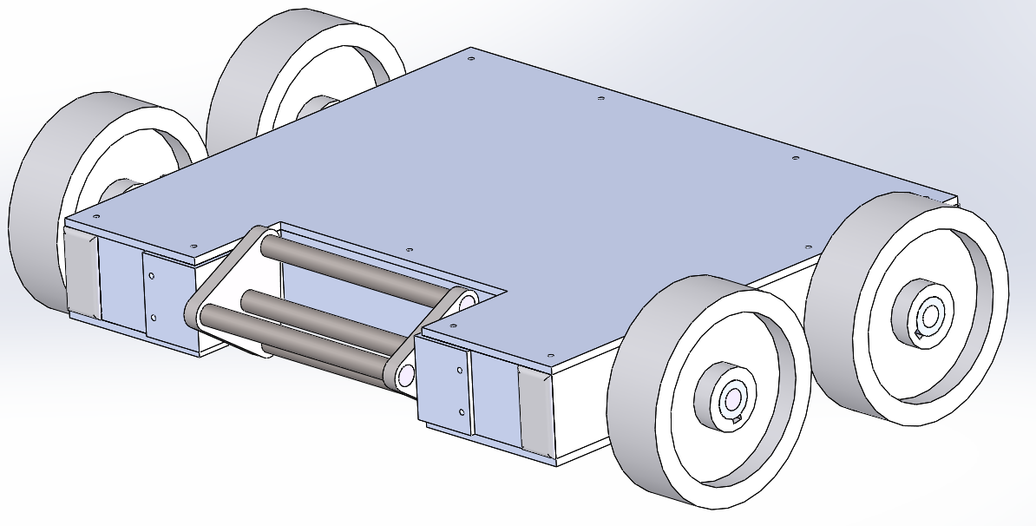

Image 1: Solid model of final robot

Using a rapidly rotating weapon as this design does and with the known arena hazards, it is probable that the robot will be flipped over at some point in the competition. Rather than design the robot to be self- righting, the team settled on a design that functions the same regardless of what side it is on. The microcontroller will be programed to change the controls based on controller input to make it easily driven upside down.

The roller weapon uses three strong half inch steel rods as it’s attacking surface. Moving them away from the center of the roller allowed the team to increase the weapon’s rotational moment of inertia without dramatically increasing the weight. All connections of the half inch steel rods to the hubs are secured with a weld to ensure weapon durability.

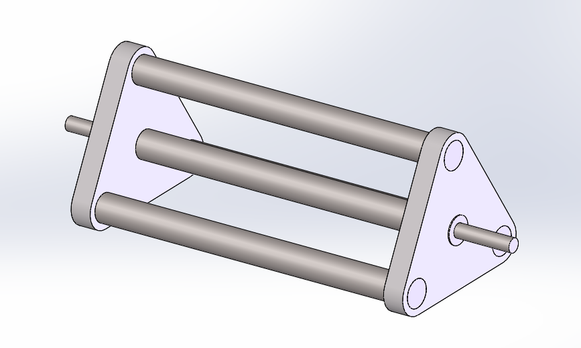

Image 2: Solid model of roller weapon

The frame can be manufactured by modifying a single length of 1 in x 2 in x ⅛ in rectangular aluminum tube, keeping the manufacturing cost of the frame low. All joints between frame pieces are welded to ensure rigidity. During the competition, the connected motor rotates the weapon at 1600 RPM.

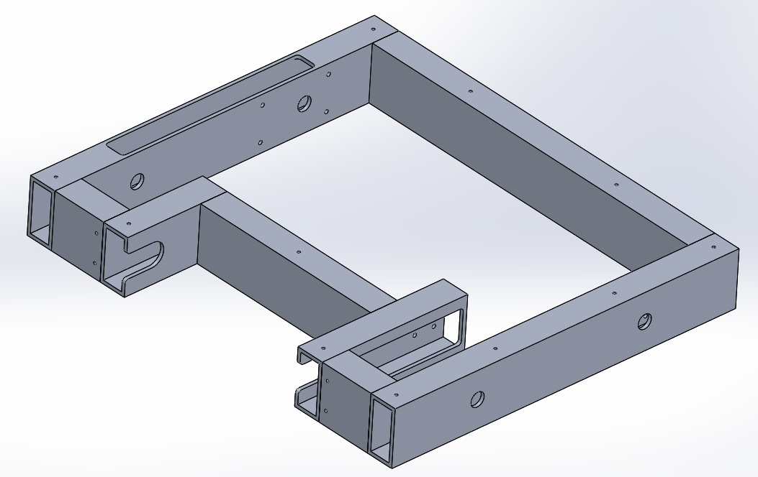

Image 3: Solid model of welded frame

The rectangular tube, in addition to adding extra rigidity to the robot, can be used to house the three belts used to transmit power in the vehicle. This keeps these weak points shielded against enemies and the environment and provides structure to keep the axles aligned. Large windows near the belts allow access during assembly, but are hidden by the top and bottom armor plates during the competition. The armor mounting holes on the top and bottom of the frame will be tapped for easy assembly and disassembly.

The design of the internal layout was carefully designed to minimize the tread of armor deformation to the internal systems.

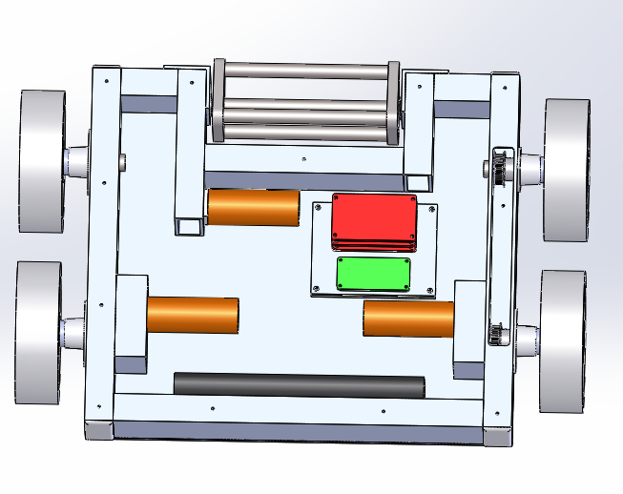

Image 4: Robot internal layout

The weapon motor is placed such that rectangular tubing close by on two sides provides a brace against impact to the armor. The motor controller stack, one of the tallest internal structures, was placed next to an uncut portion of tubing behind the weapon where it would be both strong and difficult to hit. The gearboxes of the driving motors are the same width as the frame itself, giving some more structure to the vehicle near the motors. The most vulnerable part of the frame is the side pieces, as they conceal the belts that drive the front wheels. To protect them, the wheels are externally mounted and made of a thermoplastic rubber tread and a polypropylene core, making them lightweight and durable while capable of excellent traction. They are also relatively inexpensive and quickly replaceable (due to the clamping hubs). The team deemed it preferable to lose a part that could be easily replaced between rounds than to risk permanent damage that could disqualify the robot from the competition. As such the wheels double as extra protection for the inner workings/electronics.

The electronics are mounted on an aluminum plate separated from the armor by a 0.25-inch foam pad and uses bushings in its mounting to further remove vibration.

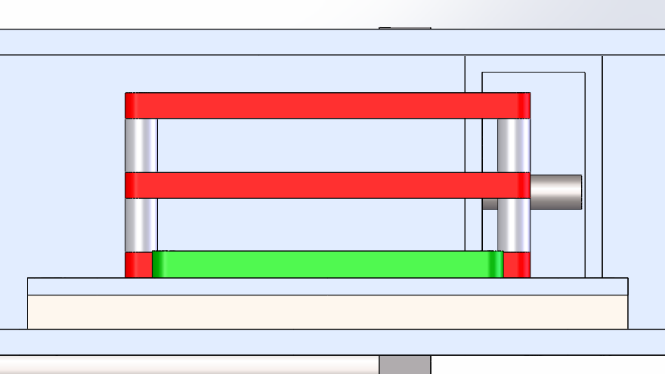

Image 5: Electronics mounting

This ensures that if the bottom armor is dented, it will affect the foam which can easily deform rather than destroying the microcontroller and motor controllers that allow the robot to function.

The drive system uses one motor to drive each side of the vehicle. This reduces the cost of the vehicle and was needed for space to allow all four wheels to be powered given the limited space available near the weapon mounting.

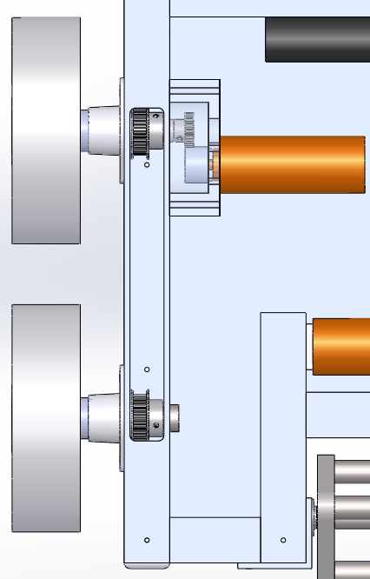

Image 6: Wheel power connection showing pulleys for timing belt

Pulleys on the front and rear axles will be connected by a timing belt which keeps then in sync with one another and transmits power from the back to the front. Even if this connection is damaged, the rear wheels will still be able to provide power from their direct geared connection to the motors. This driving configuration, often called tank controls, relies on the differential in speed between the left and right side in order to steer. This allows the robot to turn in place and reduces the number of failure points due to fragile moving parts needed to change the angle of any wheels.

The top and bottom armor plates are cut out of 3/16 in aluminum. The material keeps them light allowing the armor to be relatively thick and strong. A comparison to other armor types investigated can be found in Appendix A.

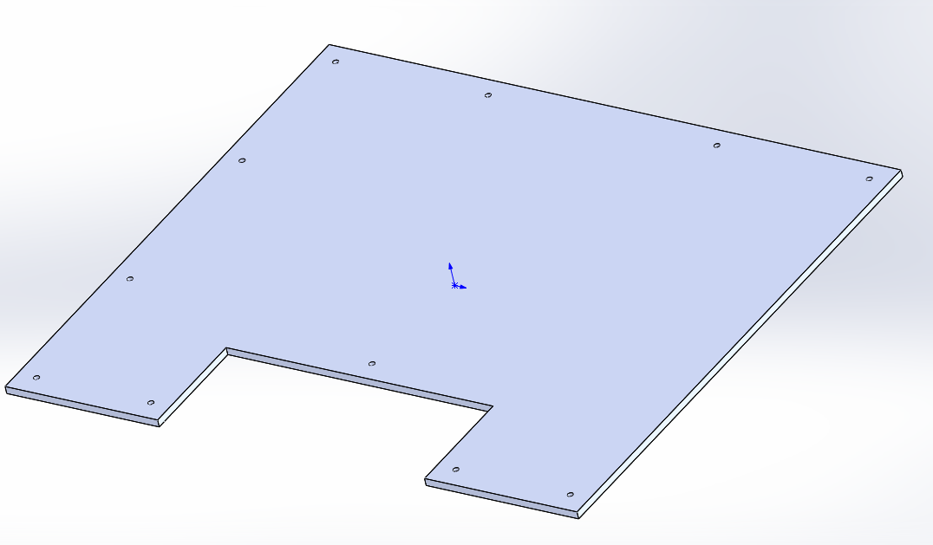

Image 7: Top Armor Plate

The combination of all of these design features results in a robot that is durable for its weight, maneuverable, and easily repaired. The weapon chosen is easy to use which is also a major consideration in competition. The driver only needs to run into opponents to use it and it can be used defensively to keep opponents at bay. The Raspberry Pi Zero W controlling the vehicle is easily programmed and easily replaced if damaged. The overall design is relatively simple to manufacture and the use of welding for the frame and weapon make the parts likely to be in the most danger strong and reliable.

# Chapter 7: Conclusion

The robot design fits all competition restrictions and is expected to perform well in the competition. The design of the robot lends itself well to quick construction with minimal machining and construction is expected to finish well ahead of the competition date, leaving plenty of time to test and refine the machine. The group members’ skills lend themselves well to the tasks which need to be performed. Between the group members the team has ample experience with the machining, welding, electrical wiring and programming that will be required in order to build the robot.

The project is in a good place and the team is preparing to purchase all the required materials, so that it will be ready to begin manufacturing at the beginning of spring semester. Manufacturing is expected to finish at the beginning of April at which point testing will begin. This will allow plenty of time to test, troubleshoot and improve the design before the competition.

# References

1). “6061 Vs 7075 Aluminum.” *The Metal Press by Onlinemetals.com*, Npdadmin, 7 Nov. 2018, metalpress.onlinemetals.com/6061-vs-7075-aluminum-alloy/.

2). ‘Arduino’, [Online], https://www.adafruit.com/category/17, 12/09/2018.

3). ‘Raspberry Pi’, [Online], https://www.raspberrypi.org/, 12/09/2018.

4). ‘Core Specifications’, [Online], https://www.bluetooth.com/specifications/bluetooth-core-specification, 12/09/2018.

5). R. Larimer P.E., Professor of Engineering, College of Engineering, Montana State University, Bozeman, Montana. Private Communication, October 25, 2018.

# Appendix A. Engineering Analysis

## A-1: Armor Plate

The armor plate of the robot that protects the internal components was loaded with a 100 lbf force applied to a 1 in diameter circle in the middle of the least supported area of the plate. This represents a large force from another robot attack and tests to see if it would damage internal components. 100 lbf was settled on as it would be a large force for a 25-pound robot to be able to apply during an attack and the location was chosen to cause the maximum deflection.

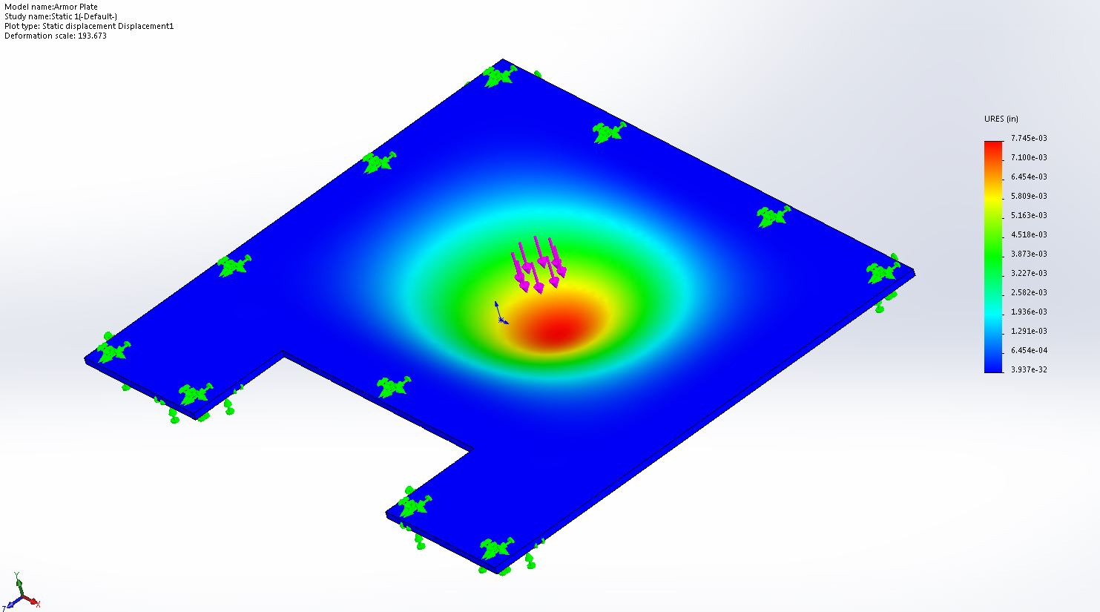

Figure 1: displacement of Armor Plate due to 100-pound force

The model was constrained in all degrees of freedom at the screw holes that hold it onto the robot, and on a 1 inch perimeter where the frame would be supporting the plate. As Figure 1 shows, the maximum deflection is 7.745e-03 inches, so this deflection does not endanger any internal components. 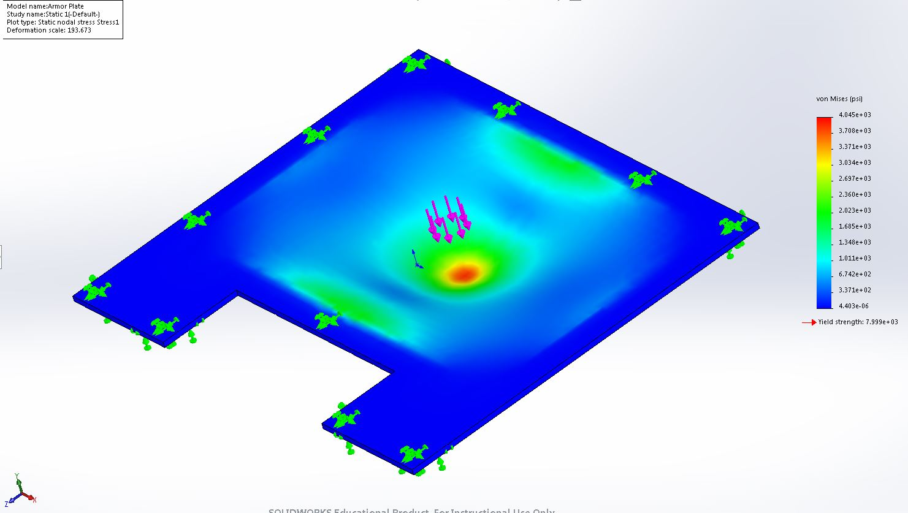

Figure 2: stress of Armor Plate due to 100-pound force

The maximum stress caused by this force is 4.045 ksi as shown in Figure 2. This gives the plate a factor of safety of 1.98 against permanently deforming from this force. This armor will do an adequate job of protecting the internal components of the robot.

The possibility of using a heavier 11-gauge steel armor plate was also investigated.

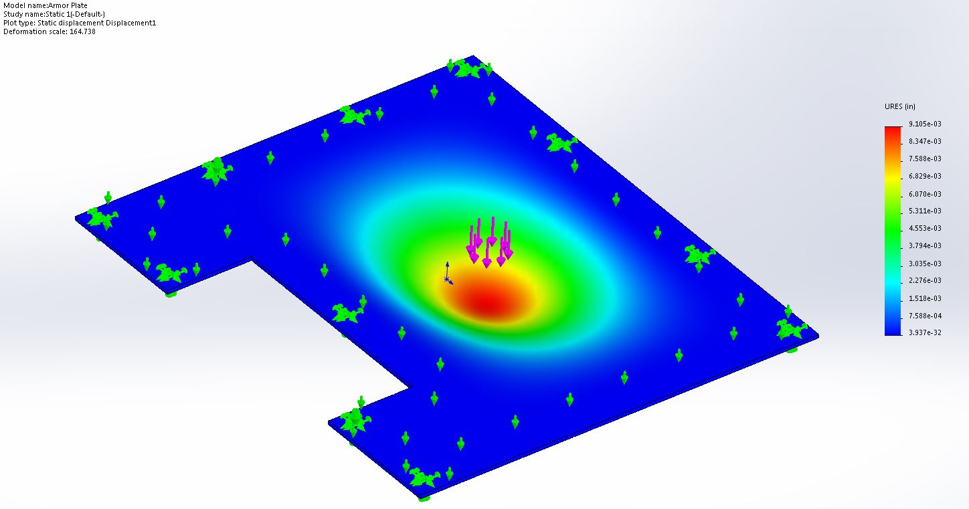

Figure 3: displacement of 11-guage steel Armor Plate due to 100-pound

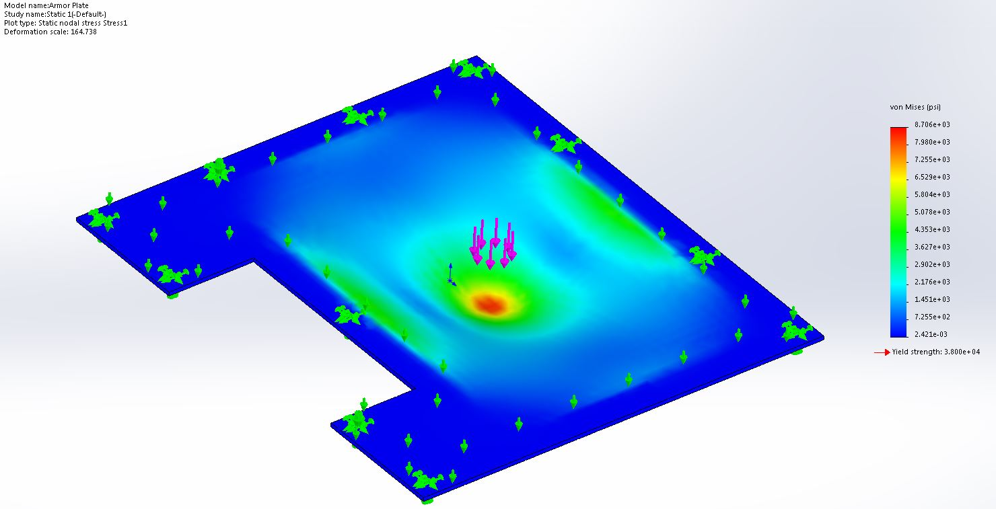

Figure 4: stress of 11-guage steel Armor Plate due to 100-pound force

From the finite element models of armor made from an 11-gauge steel plate, though it is farther from its yield stress, the deformation it permits under the same stress is greater, making it less effective at preventing the chosen failure criteria than 3/16 in aluminum, in addition to being heavier.

## A-2: Frame:

The frame provides the primary structure of the robot so its integrity is of great importance.

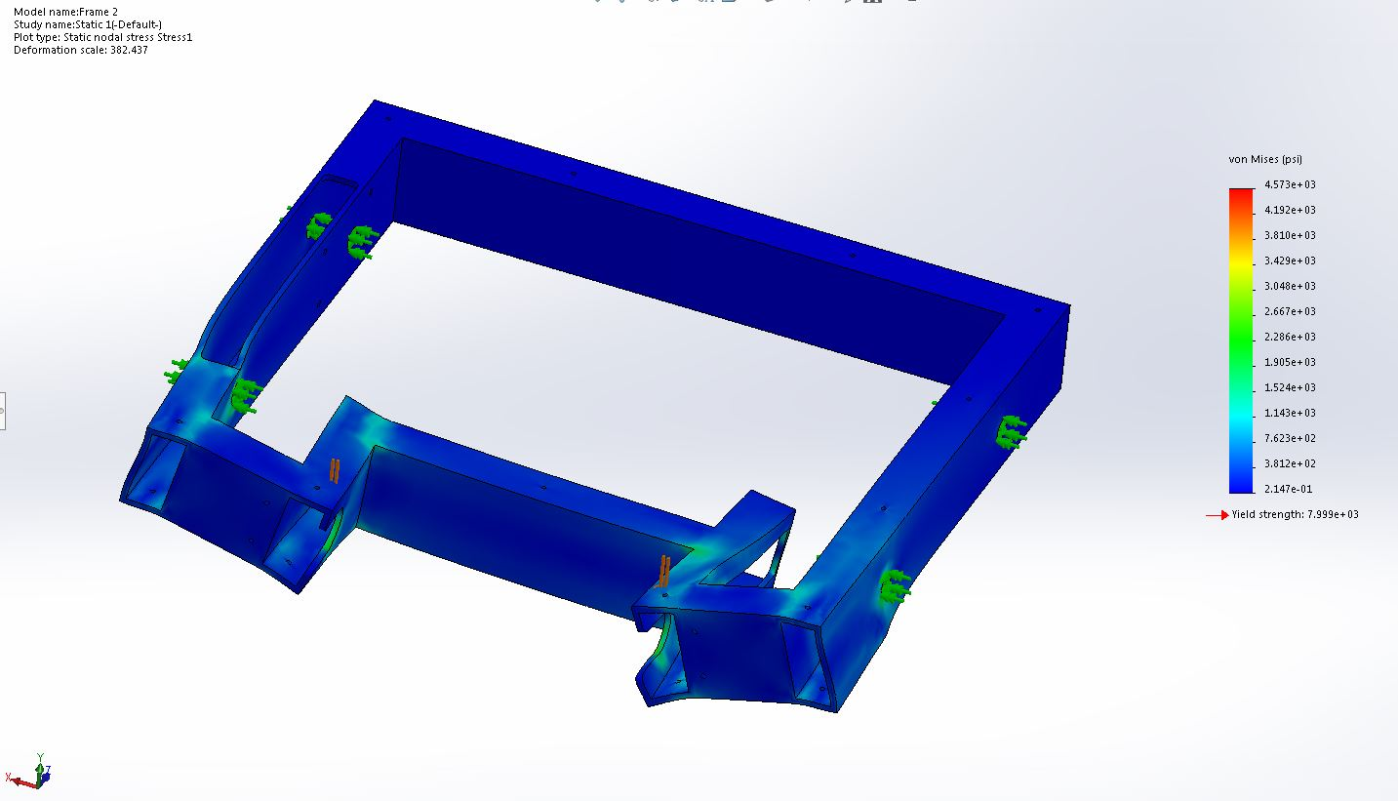

Figure 5: Stress on Frame under 200lbf force at weapon connection

To ensure the frame could withstand the force of the weapon hitting an opponent, the frame was loaded with a 100-pound force on each side where the weapon attaches to the frame, as shown in Figure 3. The axle holes were anchored in all degrees of freedom except rotation. The maximum stress appears directly below the applied forces but drops off quickly. This is likely a result of the ideal application of the force along a line rather than over an area, causing the local stress to be more concentrated. A factor of 1.75 against yielding under these conditions means that the use of the weapon is unlikely to damage the frame.

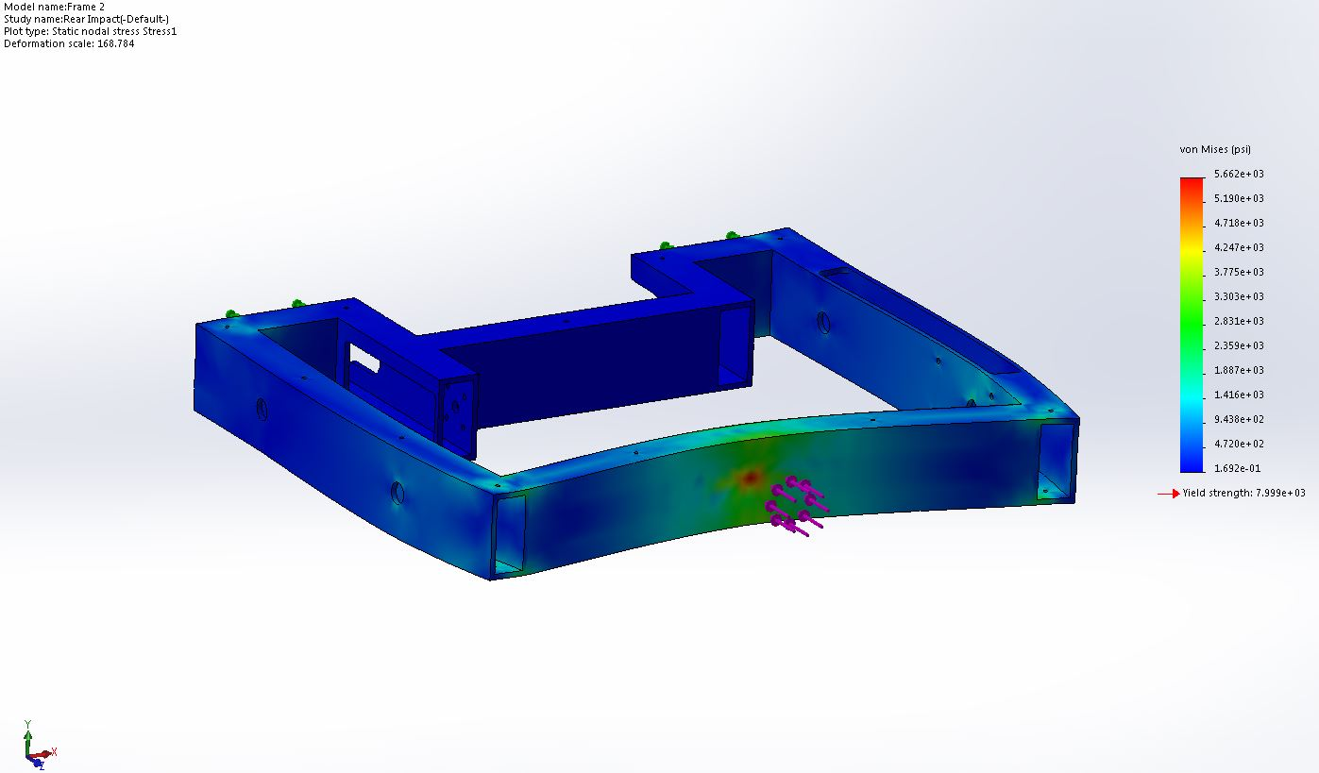

Figure 6: stress in Frame due to 100lbf force applied at rear

Analysis was also done on the frame under a 100lbf load applied to a 1 inch circle in the center of the rear of the frame to account for impacts to the back of the robot, as shown in Figure 4. The front faces were anchored in all degrees of freedom. This was chosen because the rear of the frame is its most exposed part of the structure and therefore the most likely to get hit. It is also the longest unsupported span of any piece of the frame. The analysis shows that the frame resists permanent deformation from this force by a factor of safety of 1.41. This portion of the frame is strong enough to adequately protect the robot.

# A-3: Roller

The robot’s weapon will be under large stresses as it impacts other robots and obstacles. As such, a large load of 300lbf was applied to one of its outer bars tangent to the weapon’s axis of rotation to simulate a large strike.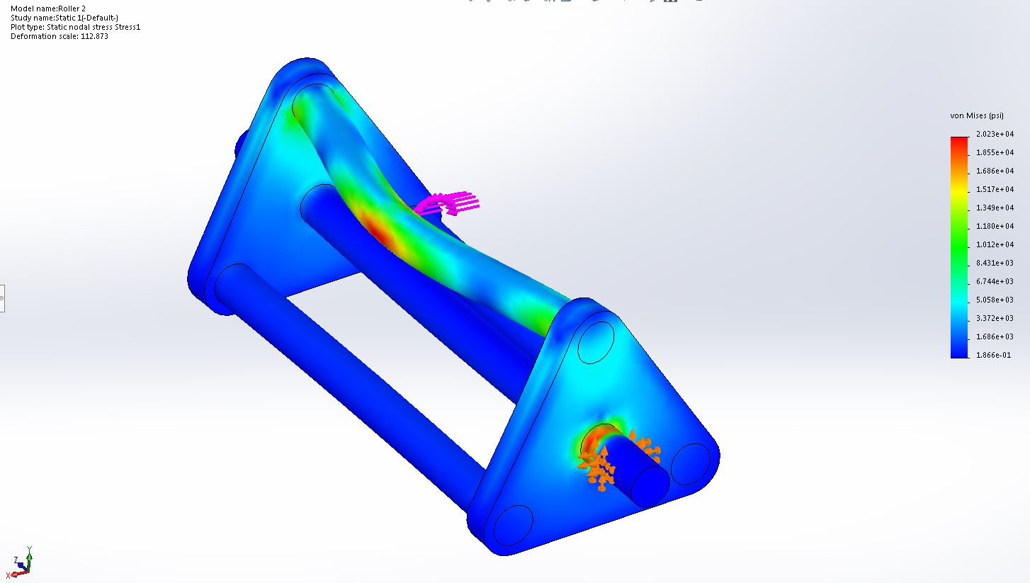

Figure 7: Stress on Roller under 300-pound force at center of striking bar

In this model, 300 lbf was applies to the center of one of the bars of the weapon and the center axle was constrained in all degreed of freedom at the points at which it attaches to the bearings. The yield strength of the steel bars is 38 ksi, giving the piece a factor of safety of 1.9 at this loading. Additionally, since in operation there is nothing attached to the roller capable of providing the 450 in-lbf (the applied motor torque at stall is 97.2 oz-in) of torque needed to resist motion under this load, the high stress area on the main axle is expected to be much lower than the conditions of this analysis predict.

Another analysis was performed using the same loading, but normal to the center axle to see how much of the main axle’s stress was the result of torque.

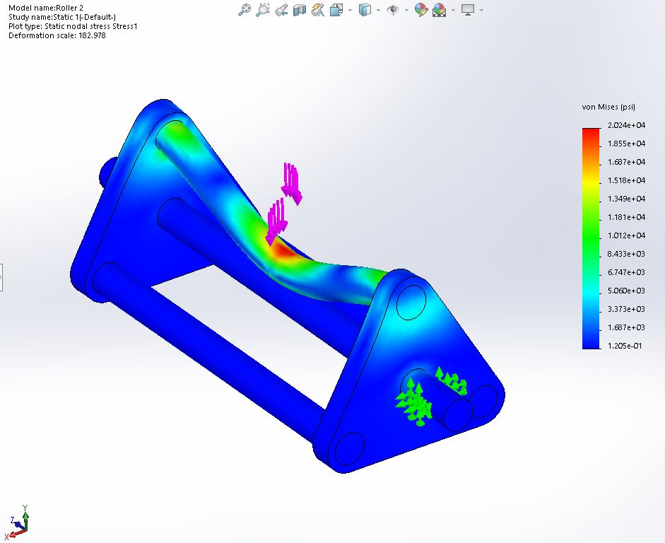

Figure 8: Stress on Roller under 300-pound force at center of striking bar, no torque

As expected, an unrealistic counter torque was the primary contributor to the stress on the center axle.

## A-5: Electronics:

### Weapon Acceleration

The weapon is meant to reach a top speed of 1600 RPM. Based on what data was available about our chosen motor, it provided an average torque of 55.51 oz-in and had an average speed of 800 rpm. This converts to a torque of 0.392 N*m and an angular speed of 83.776 rad/s. The average power was calculated:

$$P_{ave}=0.392 N*m*83.776\frac{rad}{s}=32.84 W$$

The kinetic energy was calculated from its operating speed of 1600 RPM and the moment of inertia about the axle provided by SolidWorks of 806 kg*mm^2.

$$KE=\frac{1}{2}*806 kg*mm^{2}*{10}^{-6}*\left(1600 RPM*\frac{1 min}{60 sec}*2*π\right)=11.3136 J$$

And so, the estimated time to reach speed is

$$t=\frac{KE}{P_{ave}}=0.3445 sec$$

### Power and Amperage

The power budget of the electrical systems was calculated using the length of a match and the stall amperage of the three motors. The motor stall amperage is 20A each, for a total of 60A. The raspberry pi takes a 230mA current under heavy computational load and the motor controllers did not list the amperage needed to run the control circuit. These were deemed to be negligible compared to the motors. Each round is 3 minutes, or 0.05 hours.

$$P=60A*0.05hr=3Ah$$

Our battery provides 4.2Ah. This calculation is a worst-case scenario. The robot is not expected to require full stall amperage for the majority of the round and, though no power curve is given, the no-load amperage of each motor is as low as 0.51A. The power supply was designed for the worst-case, as the exact power used each round will vary widely depending on what happened in that round. Some testing will be needed to know with more certainty how much power is likely to be consumed in a single round.

# Appendix B: Manufacturing Plan

In order to ensure delivery of a correctly assembled final project in a timely manner, the following manufacturing plan was developed. First instructions will be for individual parts, followed by instructions for sub and final assembly.

Section B-1: Armor plate Bottom (AP1)

|  |  |  |  |
| --- | --- | --- | --- |
| AP1 | Process | Tool | Time |
| 1 | Cut a piece of 3/16" aluminum to a 15"x13" rectangle | Bandsaw | 5 minutes |
| 2 | Cut 2.75" recess in the sheet as shown in the AP1 drawing | Bandsaw | 5 minutes |
| 3 | Drill the 11 M3 clearance holes along the edge of the piece as shown in the AP1 drawing | Mill | 40 minutes |
| 4 | Drill 4 more M3 clearance holes in the rectangular pattern shown in the AP1 drawing | Mill | 20 minutes |

Section B-2: Armor Plate Top (AP2)

|  |  |  |  |
| --- | --- | --- | --- |
| AP2 | Process | Tool | Time |
| 1 | Cut a piece of 1/8" thick aluminum sheet into a 3.375 " by 4.375" rectangle | Bandsaw | 5 minutes |
| 2 | Cut 2.75" recess in the sheet as shown in the AP1 drawing | Mill | 5 minutes |
| 3 | Drill the 11 M3 clearance holes along the edge of the piece as shown in the AP2 drawing | Mill | 40 minutes |

Section B-3: Electronic Mounting Plate and Assembly (EM1/EMA1)

|  |  |  |  |
| --- | --- | --- | --- |
| EMA1 | Process | Tool | Time |
| 1 | Cut 4.375" by 3.375" square of 1/4" aluminum | Bandsaw | 10 minutes |
| 2 | Tap 4 M3x.5 mm threads | Mill | 15 minutes |
| 3 | Drill 8 6 mm holes | Mill | 30 minutes |
| 4 | Insert 4 M3 press-in nuts into the 4 corner holes of part AP1, all on the same side. | Press | 10 minutes |
| 5 | Insert 8 M3 press-in nuts into the 8 remaining holes of part AP1, all on the same side as each other, opposite the previous press-in nuts. | Press |  |
| 6 | Secure the Raspberry Pi Zero to part EP1 using the small electronics mounting hole pattern with 4 10mm M3 bolts. | Screwdriver | 5 minutes |
| 7 | Put one 40mm M3 screw through each corner of one of the motor control boards so that the components on the board are facing up and the bolts extend down. |  |  |
| 8 | Flipping the motor control board over so that the bolts point up, add one 10mm aluminum spacer to each bolt. |  | 5 minutes |
| 9 | Slide another motor control board onto the bolts facing the same direction as the previous one. |  | 5 minutes |
| 10 | Repeat step 5. |  | 5 minutes |
| 11 | Repeat step 6. |  | 5 minutes |
| 12 | Use the large electronics mounting hole pattern to secure the stack to part AP1. | Screwdriver | 5 minutes |

Section B-4: Frame Back (FR1)

|  |  |  |  |
| --- | --- | --- | --- |
| FR1 | Process | Tool | Time |
| 1 | Cut 2x1 aluminum rectangular tube to a length of 13" | Bandsaw | 5 minutes |
| 2 | Drill M3 clearance hole (3.4 mm) on centerline of tube and 3.5" from end | Mill/3.4mm drill bit | 5 minutes |
| 3 | Drill M3 clearance hole (3.4 mm) on centerline of tube and 6" from first hole | Mill/3.4mm drill bit | 5 minutes |

Section B-5: Frame Side (FR2)

|  |  |  |  |
| --- | --- | --- | --- |
| FR2 (2x) | Process | Tool | Time |
| 1 | Cut 2x1 aluminum rectangular tube to a length of 13" | Bandsaw | 5 minutes |
|  | Perform operations 2-6 on 1" wide face |  |  |
| 2 | Tap M3x.5" thread on center line .5" from both edges | Mill (M3x.5 Tap) | 5 minutes |
| 3 | Cut 7.32" x .75" rectangle (starting 2.68" from the same edge the first hole was drilled on | Mill (.25" bit) | 5 minutes |
| 4 | Tap M3x.5" thread 4.25" from same referenced edge | Mill (M3x.5 Tap) | 5 minutes |
| 5 | Tap M3x.5" thread 8.75" from same referenced edge | Mill (M3x.5 Tap) | 5 minutes |
| 6 | Tap M3x.5" thread on center line .5" from opposite edge | Mill (M3x.5 Tap) | 5 minutes |
|  | *On 2" Wide Face |  |  |
| 7 | Drill .5" hole 3.179" from first referenced edge (for axle) | Mill (.5" bit) | 5 minutes |
| 8 | Drill .5" hole 6.321" from first .5" axle hole | Mill (.5" bit) | 5 minutes |
| 9 | Moving farther from the originally referenced edge, Tap M3x.5 thread .625" above and .875" from center of previous axle hole | Mill (M3x.5 Tap) | 5 minutes |
| 10 | On same horizontal line, (but on other side of .5" hole) tap M3x.5 thread 2.5" away from first tapped hole | Mill (M3x.5 Tap) | 5 minutes |
| 11 | Vertical (across 2" width) tap M3x.5" thread 1.25" below previous | Mill (M3x.5 Tap) | 5 minutes |
| 12 | On same line (horizontal), tap M3x.5 2.5" from previous and below/on same vertical line of first tap | Mill (M3x.5 Tap) | 5 minutes |

Section B-6: Frame Front (FR3)

|  |  |  |  |
| --- | --- | --- | --- |
| FR3 (2x) | Process | Tool | Time |
| 1 | Cut aluminum rectangular tube to a length of 2" | Bandsaw | 5 minutes |
| 2 | Tap M3x.5" thread .5" from horizontal edge and .25" from vertical edge | Mill (M3x.5 Tap) | 5 minutes |
| 3 | Tap M3x.5" thread 1" below previous | Mill (M3x.5 Tap) | 5 minutes |

Section B-7: Frame Short Roller Arm (FR4)

|  |  |  |  |
| --- | --- | --- | --- |
| FR4 | Process | Tool | Time |
| 1 | Cut aluminum rectangular tube to a length of 3.75" | Bandsaw | 5 minutes |
| 2 | Tap M3x.5" thread .5" from horizontal edge and .5" from vertical edge on 1" face | Mill (M3x.5 Tap) | 5 minutes |
| 3 | On same side hole was tapped (but on 2" face) cut slot for RM1 (Roller/bearing bracket) | Mill | 5 minutes |

Section B-8: Frame Roller Space (FR5)

|  |  |  |  |
| --- | --- | --- | --- |
| FR5 | Process | Tool | Time |
| 2 | Cut aluminum rectangular tube to a length of 7" | Bandsaw | 5 minutes |
| 3 | On centerline, Tap M3x.5" thread 3.5" from horizontal edge | Mill (M3x.5 Tap) | 5 minutes |

Section B-9: Frame Long Roller Arm (FR6)

|  |  |  |  |
| --- | --- | --- | --- |
| FR6 | Process | Tool | Time |
| 1 | Cut aluminum rectangular tube to a length of 5.5" | Bandsaw | 5 minutes |
| 2 | On 1" face, Tap M3x.5" thread.5" from horizontal and vertical edge | Mill (M3x.5 Tap) | 5 minutes |
| 3 | On one side of 23" face, cut 1.22" x 4" window | Mill | 5 minutes |
| 4 | On other side of 2" face,(and on centerline) cut slot for roller/bearing | Mill | 5 minutes |
| 5 | On same side of 2" face, drill the 4 M3 clearance holes for motor mount | Mill (3.4 mm bit) | 15 minutes |
| 6 | In center of 4 clearance holes, drill .2756" hole for motor | Mill (7 mm drill bit) | 5 minutes |

Section B-10: Roller Mount (RM1)

|  |  |  |  |
| --- | --- | --- | --- |
| RM1 | Process | Tool | Time |
| 1 | Cut Aluminum block down to 2"x 1.27" (.25" thick) wall with bottom 1.625" x 2" (.125" thick) protrusion | Mill | 25 minutes |
| 2 | Drill 2 M3 clearance holes as called out In RM1 drawing | Mill | 10 minutes |
| 3 | Use CNC mill to cut out .125" thick, .6" wide, tab with .425" radius | CNC mill | 15 minutes |
| 4 | Use 11/16" drill bit to drill hole in center of protruding tab | Mill | 5 minutes |

Section B-11: Roller Hub (RH1)

|  |  |  |  |
| --- | --- | --- | --- |
| RH1 (2x) | Process | Tool | Time |
| 1 | Cut 3/8" steel to 2.7" x 2.7" triangle with .75" radii at edges | CNC router | 30 minutes |
| 2 | Drill 4 .5" clearance holes for roller bars/axle | Mill (.5" bit) | 20 minutes |

Section B-12: Axle Front (AF1)

|  |  |  |  |
| --- | --- | --- | --- |
| AF1 (2x) | Process | Tool | Time |
| 1 | Cut .75" stock 1020 steel rod to 3.67" length | Bandsaw | 5 minutes |
| 2 | Turn rod down to .5" with the exception of .6" diameter (.2" long) end | Lathe | 15 minutes |
| 3 | Cut .25" long set screw slot starting .44" from .6" diameter end | Mill | 5 minutes |

Section B-13: Axle Rear (AR1)

|  |  |  |  |
| --- | --- | --- | --- |
| AR1 (2x) | Process | Tool | Time |
| 1 | Cut steel rod to 4" length | Bandsaw | 5 minutes |
| 2 | Turn rod down to .5" | Lathe | 15 minutes |
| 3 | Turn one end down to .25" diameter for .437" | Lathe | 5 minutes |
| 4 | Cut set screw slot in .25" diameter | Mill | 10 minutes |

Section B-14: .5” Bore Pulley (P1)

|  |  |  |  |
| --- | --- | --- | --- |
| P1 (4x) | Process | Tool | Time |
| 1 | Bore out (from bought pulley) .25" hole to .5" | Mill (.5" bit) | 5 minutes |

Section B-15: Gear Box

|  |  |  |  |
| --- | --- | --- | --- |
| GB1 (2x) | Process | Tool | Time |
| 1 | Mill aluminum down to 2"x1.1"x3" block | Mill | 15 minutes |
| 2 | Cut 2x1.5 (.85" deep) window | Mill | 10 minutes |
| 3 | Drill outer 4 M3 clearance holes for mounting to frame | Mill (M3x.5 Tap) | 10 minutes |
| 4 | Drill inner 4 M3 clearance holes for motor mount | Mill (M3x.5 Tap) | 10 minutes |
| 5 | Drill .5" diameter axle hole | Mill (.5") | 5 minutes |
| 6 | Drill 23/32" hole for motor mount |  | 5 minutes |

Section B-16: Roller Bar (RB1)

|  |  |  |  |
| --- | --- | --- | --- |
| RB1 (3x) | Process | Tool | Time |
| 1 | Cut steel rod to 6.5" length | Bandsaw | 5 minutes |
| 2 | Turn rod down to .498" | Lathe | 5 minutes |

Section B-17: Roller Axle (RA1)

|  |  |  |  |
| --- | --- | --- | --- |
| RA1 | Process | Tool | Time |
| 1 | Cut steel rod to 8.7" length | Bandsaw | 5 minutes |
| 2 | Turn down to .5" diameter | Lathe | 10 minutes |
| 3 | Turn one end down to .25" diameter for 1.1" | Lathe | 10 minutes |
| 4 | Turn other end down to .25" diameter for 1.1" | Lathe | 10 minutes |

Section B-18: Tube Cap (TC1)

|  |  |  |  |
| --- | --- | --- | --- |
| TC1 | Process | Tool | Time |
| 1 | 3d Print tube cap | 3d Printer | 1 hour |

Section B-19: Motor Mount (MM1)

|  |  |  |  |
| --- | --- | --- | --- |
| MM1 | Process | Tool | Time |
| 1 | Cut 1"x1" aluminum square | Mill/Bandsaw | 10 minutes |
| 2 | Drill 18 mm motor hole in center | Mill/18mm bit | 5 minutes |
| 3 | Drill 4 M3 Clearance holes for motor to mount | Mill | 15 minutes |

Section B-20: Frame Assembly

|  |  |  |  |
| --- | --- | --- | --- |
| Frame Assembly | Process | Tool | Time |
| 1 | Weld one of side frame pieces to frame back piece | SMAW | 20 minutes |
| 2 | Weld second side frame to frame back | SMAW | 20 minutes |
| 3 | Weld other end of frame side piece to FR3 | SMAW | 20 minutes |
| 4 | Weld other end of FR3 to FR4 | SMAW | 20 minutes |
| 5 | Weld FR4 to FR5 | SMAW | 20 minutes |
| 6 | Weld other end of FR5 to second FR6 | SMAW | 20 minutes |
| 7 | Weld FR6 to second FR3 | SMAW | 20 minutes |
| 8 | Weld FR3 to frame side (FR2) | SMAW | 20 minutes |

Section B-21: Wheel/Axle Assembly:

|  |  |  |  |
| --- | --- | --- | --- |
|  | Process | Tool | Time |
| 1 | Place 4 bored out pulleys (P1) inside FR2 (Frame side) windows with belts around both pairs |  | 5 minutes |
| 2 | Insert AR1 into FR2 axle hole/bearing/pulley and tighten pulley set screw |  | 5 minutes |
| 3 | Place gear on ¼” part of axle and tighten set screw | Screwdriver/ Drill | 5 minutes |
| 4 | Mount motor to gear boxes and tighten set screw of pinion gear onto motor shaft | Screwdriver/ Drill | 5 minutes |
| 5 | Mount gear box to frame and make sure gear teeth mesh | Screwdriver/ Drill | 5 minutes |
| 6 | Bolt both bearings on FR2 | Screwdriver/ Drill | 5 minutes |
| 7 | Press fit both wheel hubs into wheel bores | Press | 10 minutes |
| 8 | Insert AR1 into FR2 axle hole/bearing/pulley |  | 5 minutes |
| 9 | Insert all press fit hubs into wheel bores |  | 5 minutes |
| 10 | Tighten wheel hub clamp onto axle | Screwdriver/ Drill | 5 minutes |
| 11 | Repeat step 10 - 18 for other side | Screwdriver/ Drill | 15 minutes |
| 12 | Insert AF1 into frame pulley and bearing from inside of frame so that .6" diameter head stops at frame |  | 5 minutes |
| 13 | Tighten pulley set screw | Screwdriver/Drill | 5 minutes |
| 14 | Clamp wheel hubs onto end of axle | Screwdriver/Drill | 5 minutes |
| 15 | Repeat steps 20-22 for other side | Screwdriver/Drill | 10 minutes |

Section B-22: Roller Assembly

|  |  |  |  |
| --- | --- | --- | --- |
|  | Process | Tool | Time |
| 1 | Press fit flanged bearings into RM1 (2x) | Press | 5 minutes |
| 2 | Place roller bars and roller axle into roller hub (RH1) |  | 5 minutes |
| 3 | Weld Roller hub in place | SMAW | 30 minutes |
| 4 | Place second roller hub in place at other end of roller |  | 5 minutes |
| 5 | Weld second roller hub in place | SMAW | 30 minutes |
| 6 | Slide bearings with roller mount (RM1) onto both 1/4" ends of roller axle |  | 5 minutes |
| 7 | Slide 1/4" 24 tooth pulley onto end of roller axle and tighten set screw | Screwdriver | 5 minutes |
| 8 | Place 6 mm pulley inside FR6 (long roller arm) with bet around it |  |  |
| 9 | Secure motor mount to FR6 | Screwdriver/Drill | 5 minutes |
| 10 | Secure motor to motor mount through pulley bore | Screwdriver/Drill | 5 minutes |
| 11 | Tighten set screw from pulley to motor | Screwdriver/Drill | <5 minutes |
| 12 | Slide roller/brackets into place at front of bot, slip belt over pulley, and screw brackets into frame | Screwdriver/Drill | 10 minutes |
| 13 | Press tube caps into place |  | 5 minutes |

Section B-23: Finishing up/Making Repairs

|  |  |  |  |
| --- | --- | --- | --- |
|  | Process | Tool | Time |
| 1 | Bolt AP1 (with electronic panel) into frame | Screwdriver/ Drill | 5 minutes |
| 2 | Mount battery (with velcro) to FR1 |  |  |
| 3 | Wire motors to raspberry pi/motor control panel |  | 5 minutes |
| 4 | Wire battery to control panel/motors |  | 5 minutes |
| 5 | Bolt in AP2 to frame | Screwdriver/drill | 5 minutes |
| 6 | Test bot |  |  |

# Appendix C: Project Schedule/Management Plan

# General Roll assignment:

Based on each group members particular experience, general rolls were assigned for building/assembly of the bot.

Electronics: Assigned to Ivan for mechatronics minor/experience

Fabrication: Assigned to Cole for FEA/welding/machining through MET.

Organization/model management: Assigned to Nishagar

# Term Meeting Schedule/ Location:

This varies by week due to everyone’s work schedule, however all three gather every Wednesday at 2:00 pm to touch base, assign responsibility until the following meeting if we are unable to gather again, and otherwise decide our next meeting time before the following Wednesday. This time is also used to consult with our advisor, Professor James Black.

# File Sharing

During the first scheduled meeting it was decided that GitHub would be the primary method of editing/sharing files via a shared repository. It is excellent at saving old versions of texts, spreadsheets, and models, and each member has an individual copy on his hard drive until they are ready to be merged.

Aside from github, weekly decisions were recorded as they were made (either during group meetings or through group emails and texts) in the progress memo by that weeks assigned note taker, and were usually implemented into the final design/budget immediately.

# Group Leadership Schedule/Member Assignments:

# 9/12/18 Leader: Cole

* Meet advisor and set up weekly meeting time/place
* Deliver first progress memo
  + Assigned to group

# 9/19/18 Leader: Cole

* Level 1 requirements started
* Ongoing group rules document updated
* Wrote problem statement
  + Assigned to Ivan Albert
* Started Gantt chart
  + Assigned to Cole Trugman
* Start background section
  + Assigned to Nishagar

# 9/26/18 Leader: Ivan

* In coming week will start on design specifications
* Combined individual background sections

# 10/03/18 Leader: Ivan

* Nishagar and Cole were assigned to Level 1 Design Specifications
* Ivan was assigned to Design alternatives.
  + - Tables ranked -2 to 2 gives a clear picture of ideas and their effectiveness
* Discussed possible design and the requirements
  + - Can have both fast rollers in the front, and the wedge in the back as a defense weapon system
    - The direction of the rollers effects the motion of the bot when hits the opponent.

# 10/10/18 Leader: Nishagar

* Turn in design specs and alternatives draft
* Decided to design for a minimum pushing/push resisting force of 20 lb.
* Decided to design for a minimum speed of about 1 fps both as a defensive tactic as well and a way to make the wedge offensive.
* Discussed utilizing aluminum 6063 for its light weight and easy machinability/weldability with the possibility of implementing a thin (1/8”) layer of ar400 steel to protect the soft aluminum
* See “design specs” for other choices made this week.

# 10/17/18 Leader: Nishagar

* Update Master Project Plan (Started virtual design journal through github where it is accessible/ changeable for all members to record design ideas)
  + Assigned to Cole
* Started google doc for design journal/ place for sharing new thoughts/design ideas.
* Turn in weekly progress memo

# 10/24/18 Leader: Cole

* Perform peer review
  + Assigned to group
* Prepare/present preliminary design
  + Assigned to group (Meet Saturday 10/20 to finalize powerpoint)

# 10/31/18 Leader: Cole

* FMEA
  + Electronics Assigned to Ivan
    - Microcontroller (motor control), Battery, wiring, code, Drive/Weapon Motor, Peripheral Controller,
  + Assigned to Cole:
    - Roller failures (Bent axle, motor/roller connection, )
    - Chassis (Component protection, structural integrity)
  + Assigned to Nishagar
    - Manufacturing/Process (Tolerances, machining, assembly issues, competition rules)
    - Wheel Sub-assembly (bent/sheared axle, shape abnormalities, lost/damaged wheel, damaged bearing)

# 11/7/18 Leader: Ivan

# Master Project Schedule Update

* + Assigned to Ivan
* Division of jabs for the coming week
  + Nishagar assigned to failure calculations
  + Ivan assigned to component selection
  + Cole assigned to model finalization

# 11/14/18 Leader: Ivan

* Progress Memo
  + Assigned to Cole

# 11/21/18 Leader: Nishagar

* Progress Memo
  + Assigned to Ivan

# 11/28/18 Leader: Nishagar

* Critical Design Review (CDR)
  + Group assignment
* Draft Analysis and Manufacturing Plan Appendix
  + Assigned to Cole and Nishagar
* Progress Memo
  + Assigned to Ivan

# 12/5/18 Leader: Cole

* Progress Memo
  + Assigned to Nishagar
* Course Evaluation
  + Assigned to each member of the team
* Peer Evaluation
  + Assigned to each member of the team
* Advisor Evaluation
  + Assigned to each member of the team

# 12/12/18 Leader: Cole

* Final written report due Monday (Includes "Drawing Package"  
  and "Manufacturing Plan" Appendices, Updated Master Project Schedule, and all other elements defined on website format guide.)
  + Assigned to group
* Complete orders and supporting documentation
  + Assigned to Ivan
* Deliver CDRs by Tuesday 6:00 pm
  + Assigned to Cole
* Progress Memo
  + Assigned to Nishagar

Gantt Chart

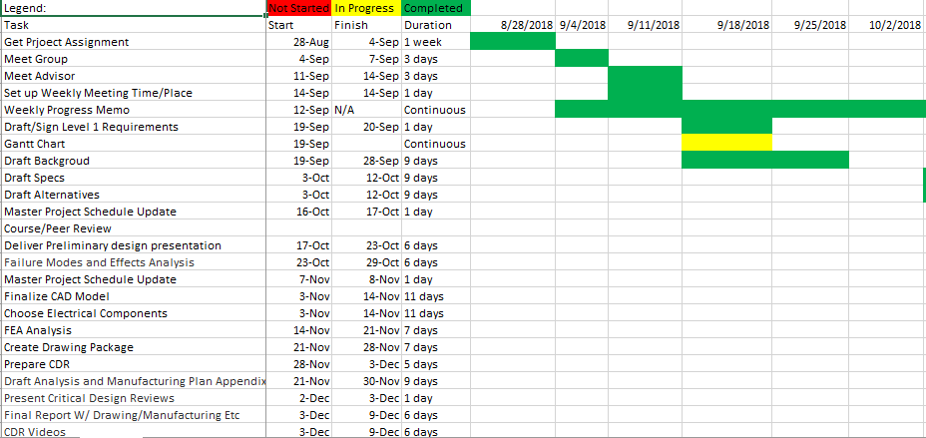

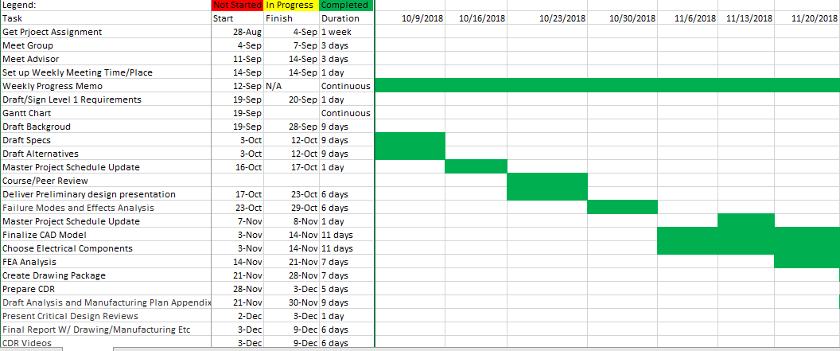

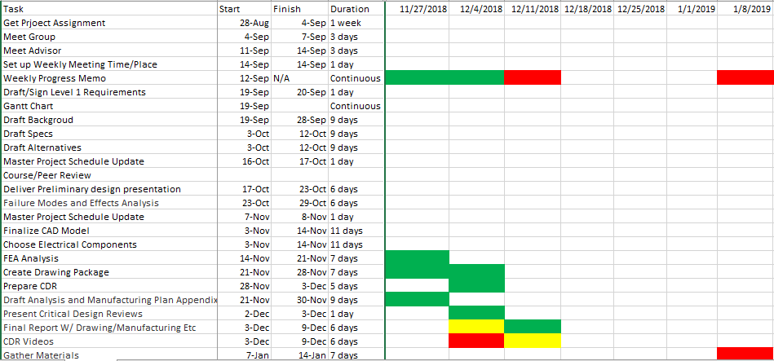

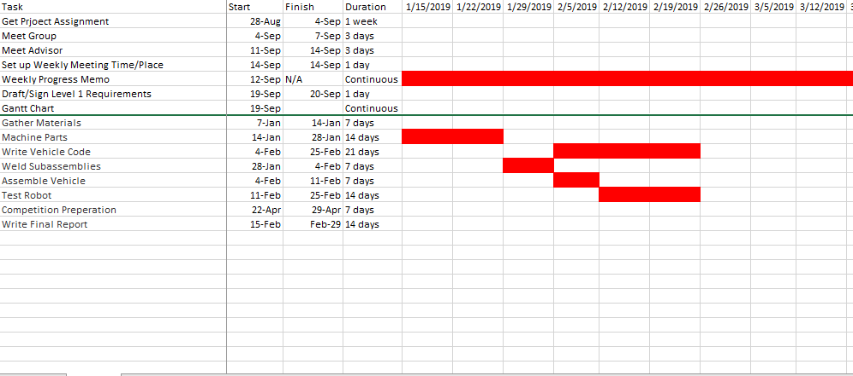

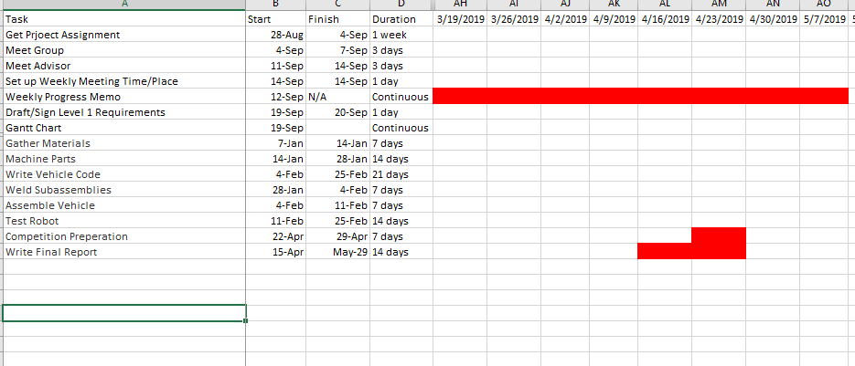

# Appendix D: Purchased Part List

# Appendix E: Engineering Drawings







# Appendix F: Economic Analysis

The budget plan given in this section is the expected cost to build the battlebot. The team will start ordering the parts by the mid of December 2018: after finalizing the design.

## Table D-1: Materials need to be Purchased

|  |  |  |  |  |
| --- | --- | --- | --- | --- |
| **Part Number** | **Description** | **Quantity** | **Unit cost** | **Total Expected Cost** |
| 1 | 165 RPM HD Premium Planetary Gear Motor | 2 | $39.99 | $79.98 |
| 2 | Cytron 13A, 5-30V Single DC Motor Controller | 4 | $13.82 | $55.28 |
| 3 | Raspberry Pi Zero W | 2 | $10.00 | $20.00 |
| 4 | Tenergy NiMH 12V 4200mAh Rechargeable Battery Pack | 2 | $69.99 | $139.98 |
| 5 | RC Servo BEC UBEC 3A 5V ( Receiver servo Power supply) | 1 | $7.99 | $7.99 |
| 6 | 1,621 RPM HD Premium Planetary Gear Motor | 1 | $39.99 | $39.99 |
| 7 | 6063-T52 Aluminum Rectangle Tube (2X1X1/8 Wall) | 1 | $32.15 | $32.15 |
| 8 | 3/16” Aluminum Plate (2’x3’) | 1 | $107.00 | $107.00 |
| 9 | 5/8" Hot Rolled A-36 Steel Round | 1 | $5.14 | $5.14 |
| 10 | 1/2" Hot Rolled A-36 Steel Round | 1 | $6.60 | $6.60 |
| 11 | Bearing | 4 | $11.00 | $44.00 |
| 12 | Roller Bearing | 2 | $10 | $20.00 |
| 13 | Pulley | 4 | $16.00 | $64.00 |
| 14 | Driving Belt | 2 | $6.00 | $12.00 |
| 15 | Gears | 2 | $22.00 | $44.00 |
| 16 | Gears | 2 | $13.00 | $26.00 |
| 17 | 5" wheels/hubs | 6 | $16.00 | $96.00 |
| 18 | Screws | 1 | $20.00 | $20.00 |
|  |  | **Total** |  | $820.11 |

The manufacturing plan is mostly based on CNC machining and welding. The screws will be used to fasten the components to the base. So, the estimated manufacturing expenses are listed below in the table. Fortunately, these manufacturing costs are waived by allowing the team to work and use the materials in the university makerspace for free.

## Table D-2: Manufacturing Cost

|  |  |  |  |
| --- | --- | --- | --- |
| **Description** | **units** | **Unit cost** | **Total expected cost** |
| CNC lathe | 3 hrs | $90/ hr | $ 270.00 |
| CNC milling | 3 hrs | $90/ hr | $ 270.00 |
| Welding | 5 hrs | $60/ hr | $ 300.00 |
| Electrodes for welding | 2 boxes | $19.97/ Box | $ 39.94 |
| Conventional milling | 4 hrs | $75/ hr | $ 300.00 |
| Conventional turning | 4 hrs | $75/ hr | $ 300.00 |

# Appendix G: Project Academic Assessment

|  |  |  |
| --- | --- | --- |
| Course number | Course | How it helped |
| EGEN 201 | Statics | Used to calculate the friction provided, minimum force from friction |
| EGEN 205 | Mechanics of Materials | Used to calculate torque, bending stress, shear stress of the structures |
| EMEC 103 | Computer Aided Engineering 1 | SolidWorks modelling, assemblies and drawing packages knowledge to start modelling |
| ETME 215 | Manufacturing Processes | Understanding of how the parts are to be manufactured |
| EMEC 405 | Finite Element Analysis | Used to calculate how failure of each selected components occur |
| EMEC 342 | Machine component Design | Understanding of what bearings, and shaft features to be used |
| EGEN 310 | Multidisciplinary Design | Experience working with a group, with various helpful intro to the project management |
| EELE 250 | Circuits, Devices and Motors | Internal wiring of the vehicle |
| EELE 371 | Microprocessor HW and SW Systems | Experience working with microcontrollers and using them to communicate with other |
|  |  |  |
|  |  |  |